|  |
| --- |
|  |
| Iterative and Incremental Development |
| Software Development |

|  |
| --- |
| Jincy P Janardhanan |

1 Iterative and Incremental Development 2

1.1 Iterative design 2

1.2 Incremental build model 2

1.2.1 Waterfall model 3

1.2.1.1 Feasibility Study 3

1.2.1.2 Requirements Analysis and Project Planning 3

1.2.1.2.1 System Requirements 3

1.2.1.2.2 Software Requirements 3

1.2.1.2.3 Requirements Analysis 3

1.2.1.2.3.1 Functional Requirements 3

1.2.1.2.3.2 Non - Functional Requirements 3

1.2.1.2.4 Planning 4

1.2.1.3 System Design 4

1.2.1.3.1 System Architecture 5

1.2.1.3.2 Database Design 5

# Iterative and Incremental Development

* 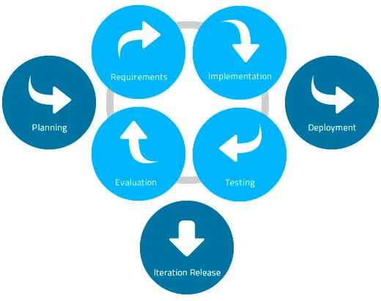Combination of iterative design and incremental build model for software development.

## Iterative design

* 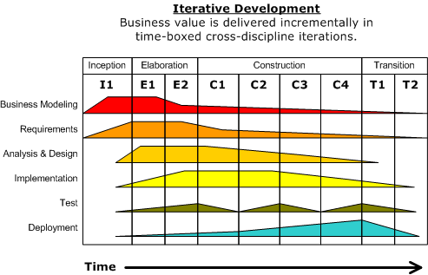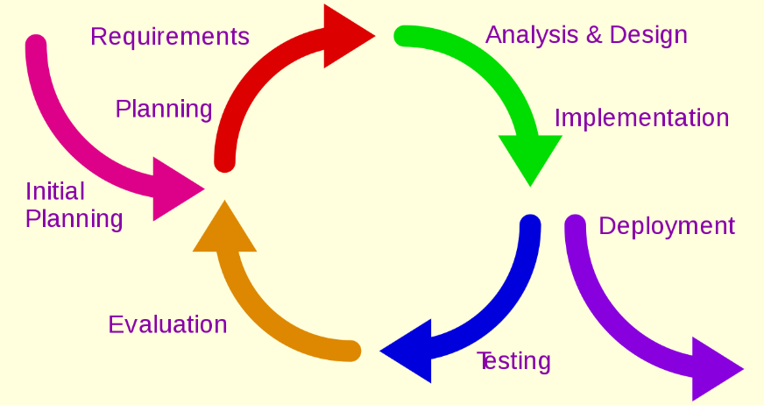A design methodology based on cyclic process of prototyping, testing, analyzing and refining the product.

## Incremental build model

* A design methodology where the product is designed, implemented and tested incrementally until all requirements are satisfied.
* Product is divided into a number of components, each of which is designed and built separately.
* 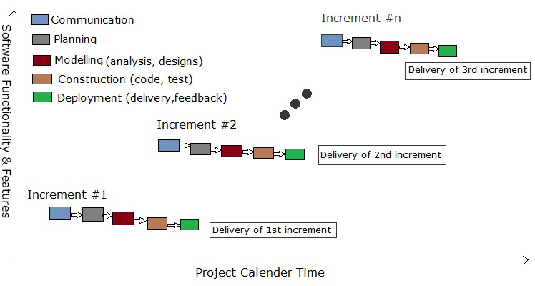It implements the waterfall model incrementally.

### Waterfall model

* A development model which breaks down project activities into a linear sequence of activities.

#### Feasibility Study

* Identify whether the system to be developed is technically, economically and operationally feasible within the allocated schedule for development.

#### Requirements Analysis and Project Planning

##### System Requirements

* Pre-requisite hardware and software requirements to implement the proposed system (software to be developed).

##### Software Requirements

* Conditions and capabilities that the system being developed must possess.

##### Requirements Analysis

* Analyze requirements to identify various types of requirements.
* After analysis, the software requirements are specified and documented in Software Requirements Specification (SRS) document.

###### Functional Requirements

* Necessary functions that the system must be able to do. #Capabilities
* Functions take some input, process them, and produce some output.

###### Non - Functional Requirements

* A criteria or condition that the system must satisfy.
* They can be used to judge the performance of a system.

##### Planning

* Identify all works required for doing the project and allocate different tasks to individual/a group of team members and assign deadlines for completion of each task.

**Detailed diagram for waterfall model**

#### System Design

* In this phase, a high-level design for the system is created which includes -
  + System architecture
  + Database design
  + Brief mention of all the platforms, systems, services, and processes the product would depend on
  + Brief description of relationships between the modules and system features

#Documented using system architecture

##### System Architecture

* System architecture defines the structure, behavior and views of a system.
* It contains a fundamental organization of the system including its components, relationships of components with each other and the environment, and the principles for design and evolution (development) of the system.

##### Database Design

* Organization of data according to a database model.
* A database model determines the logical structure of a database and determines in which manner data can be stored, organized and manipulated.
* A database design classifies data and identifies their inter-relationships.

Data Modelling in MongoDB

* Database design in MongoDB is called data modelling.
* In MongoDB, a table in SQL is called a collection.
* A row in a table is identified by a document.
* Two types of data modelling are possible in MongoDB -
  + Embedded Data Modelling - All related data are stored in a single document; it is a denormalized (not normalized) data model
  + Normalized Data Modelling - Related data are stored in different documents (normalized) and accessed using references
* Steps for Embedded Data Modelling:
  + Identify queries
  + Define Schema